MVS 2023 MVS Grade 9 Fundraiser
FUNDRAISER

The Grade 9 Class is doing a fundraiser to raise funds for their yearend school trip. They are selling ice cream and pies. The orders all need to be in by Dec. 2 and delivery date is Dec. 12. The Pie prices are all $15.00/pie and the ice cream has prices listed beside each flavor. Last year the Saskatoon pies sold out so get your orders in early. All pies were delicious. Peach was a new one but soooooo good! You can Etransfer the school mvsfees@westwind.ab.ca or cash/cheque made out to Mountain View School.
French Vanilla |  | $ 55.00
Black Cherry |  | $ 55.00
Butter Pecan |  | $ 55.00
Maple Walnut |  | $ 55.00
Cookie's n Cream |  | $ 55.00
Heavenly Hash |  | $ 55.00
Chocolate Caramel Cup |  | $ 55.00
Chocolate Chip Cookie Dough |  | $ 55.00
Caramel Praline |  | $ 55.00
Chocolate Fudge Brownie |  | $ 55.00
Vanilla |  | $ 45.00
Mint Chip |  | $ 45.00
Tiger Tail |  | $ 45.00
Blueberry Cheesecake |  | $ 45.00
Bubble Gum |  | $ 44.00
Cotton Candy |  | $ 44.00
Pies |  | $15.00
Saskatoon
Peach
Apple

FLAVORS OF ICE CREAM AND COST

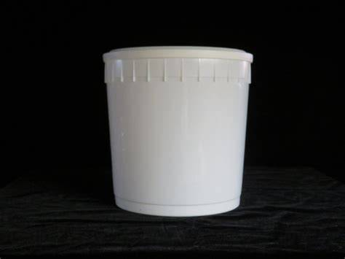

If you would like to order, you can use the QR Code which will take you directly to the form
Or tell me and I will order for you and pay me, or etransfer, or cash.
