Mountain View Christmas Program Costumes
2024

Grade 9 Class

Costume:
Girls: Red Plaid Shirts and Black pants or skirts
Boys: Green Plaid Shirts and Blue Jeans
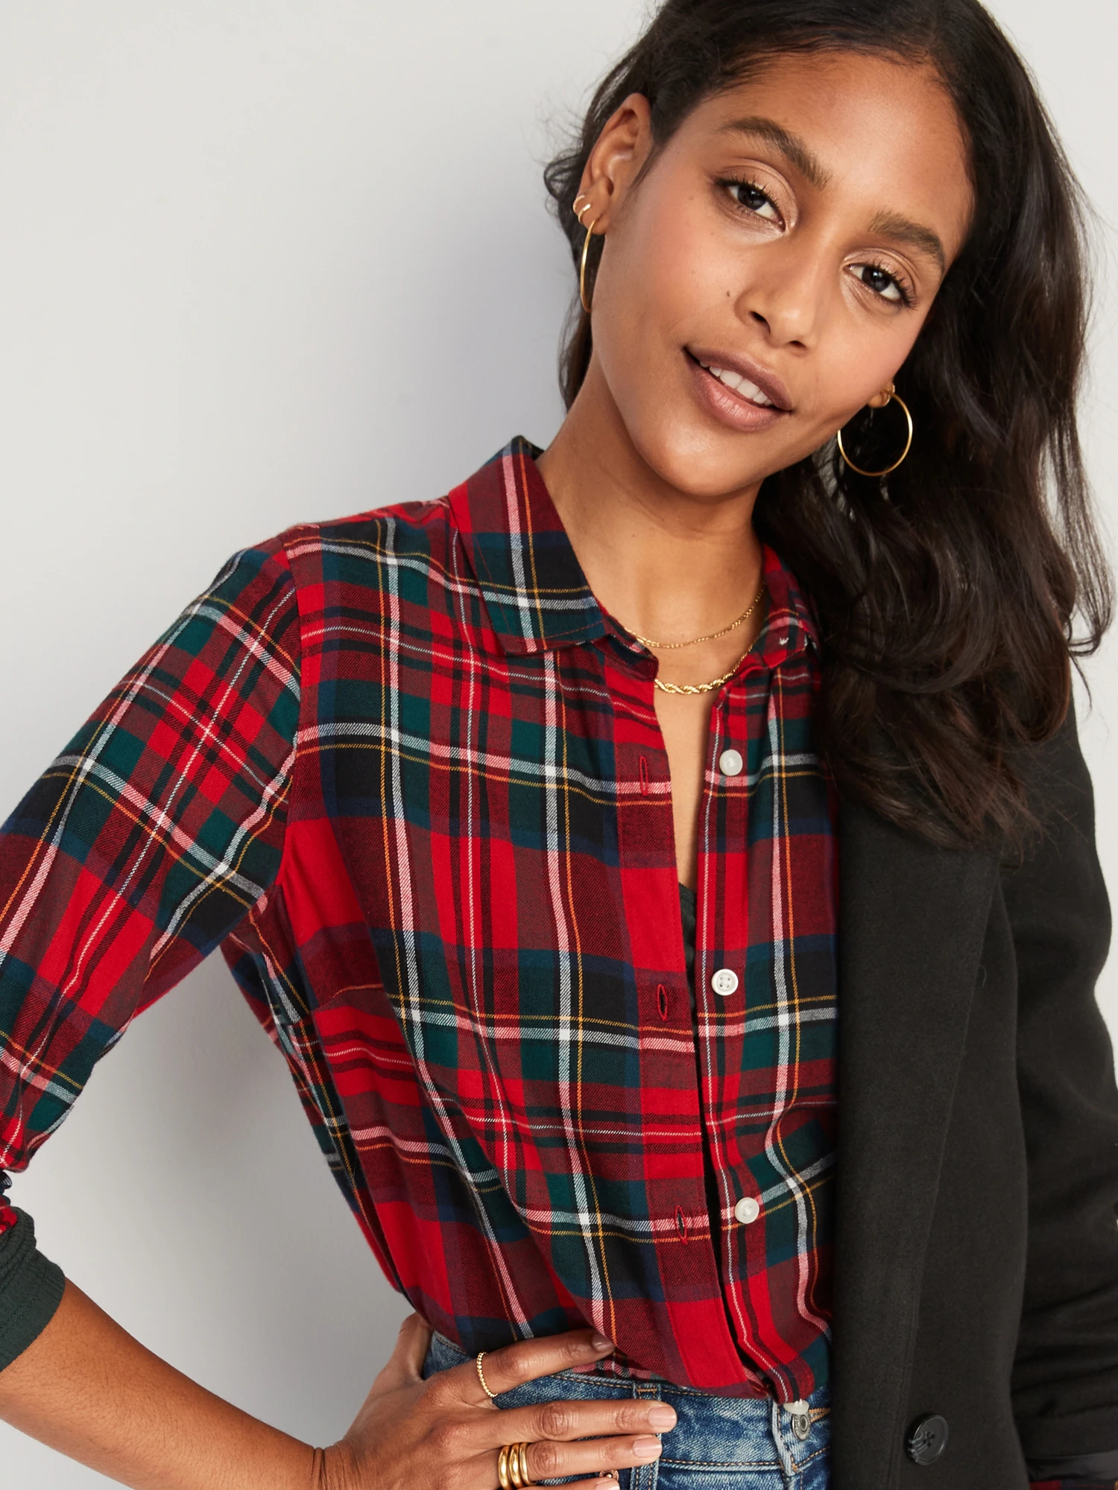
Decide as a group how to Jazz your costume up to make it more Christmas themed. Eg. Black tulle skirts with tights & add spray sparkle for the girls, black shoes, Santa hats for the boys, etc.
